Client Name:
Date of Loss:
Current Lien Amount: % of final settlement

NOTICE OF CLAIM OF ATTORNEY’S LIEN PURSUANT TO RCW 60.40.010

NOTICE IS HEREBY GIVEN that GOLD MEDAL INJURY LAW claims a lien for its services upon the claims for relief on behalf of ___________________________ against and any person, entity, or insurance company, legally liable for damages as a result of an incident occurring on ___________________, including, but not limited to: negligence, bad faith, breach of contract, breach of the covenant of good faith and fair dealing and malpractice (the “claim”).
GOLD MEDAL INJURY LAW claims a lien upon any and all property or amounts recovered (“the Recovery”) that may become available on behalf of ___________________. Said claim against ___________________________recovery shall be % of all gross amounts recovered from any source, specifically including, but not limited to, any recovery from third parties, uninsured motorist, and/or underinsured motorist coverage and 40% after the filing of a formal lawsuit.
GOLD MEDAL INJURY LAW
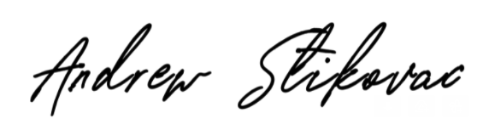
By:

Andrew Stikovac, Esq.
Washington State Bar Association No. 58020

Signature Date
© Insurance Services Office, Inc., 2013. ISO, the ISO logo, ISO ClaimSearch, Verisk Analytics, and the Verisk Analytics logo are registered trademarks and Verisk, Verisk Insurance Solutions, and the Verisk Insurance Solutions logo are trademarks of Insurance Services Office, Inc. AIR Worldwide and the AIR Worldwide logo are registered trademarks of AIR Worldwide Corporation. Xactware is a registered trademark of Xactware Solutions, Inc. All other product or corporate names are trademarks or registered trademarks of their respective com

